Class test-4

Aaditya partiban

192211037

#to print area of rectangle using structure

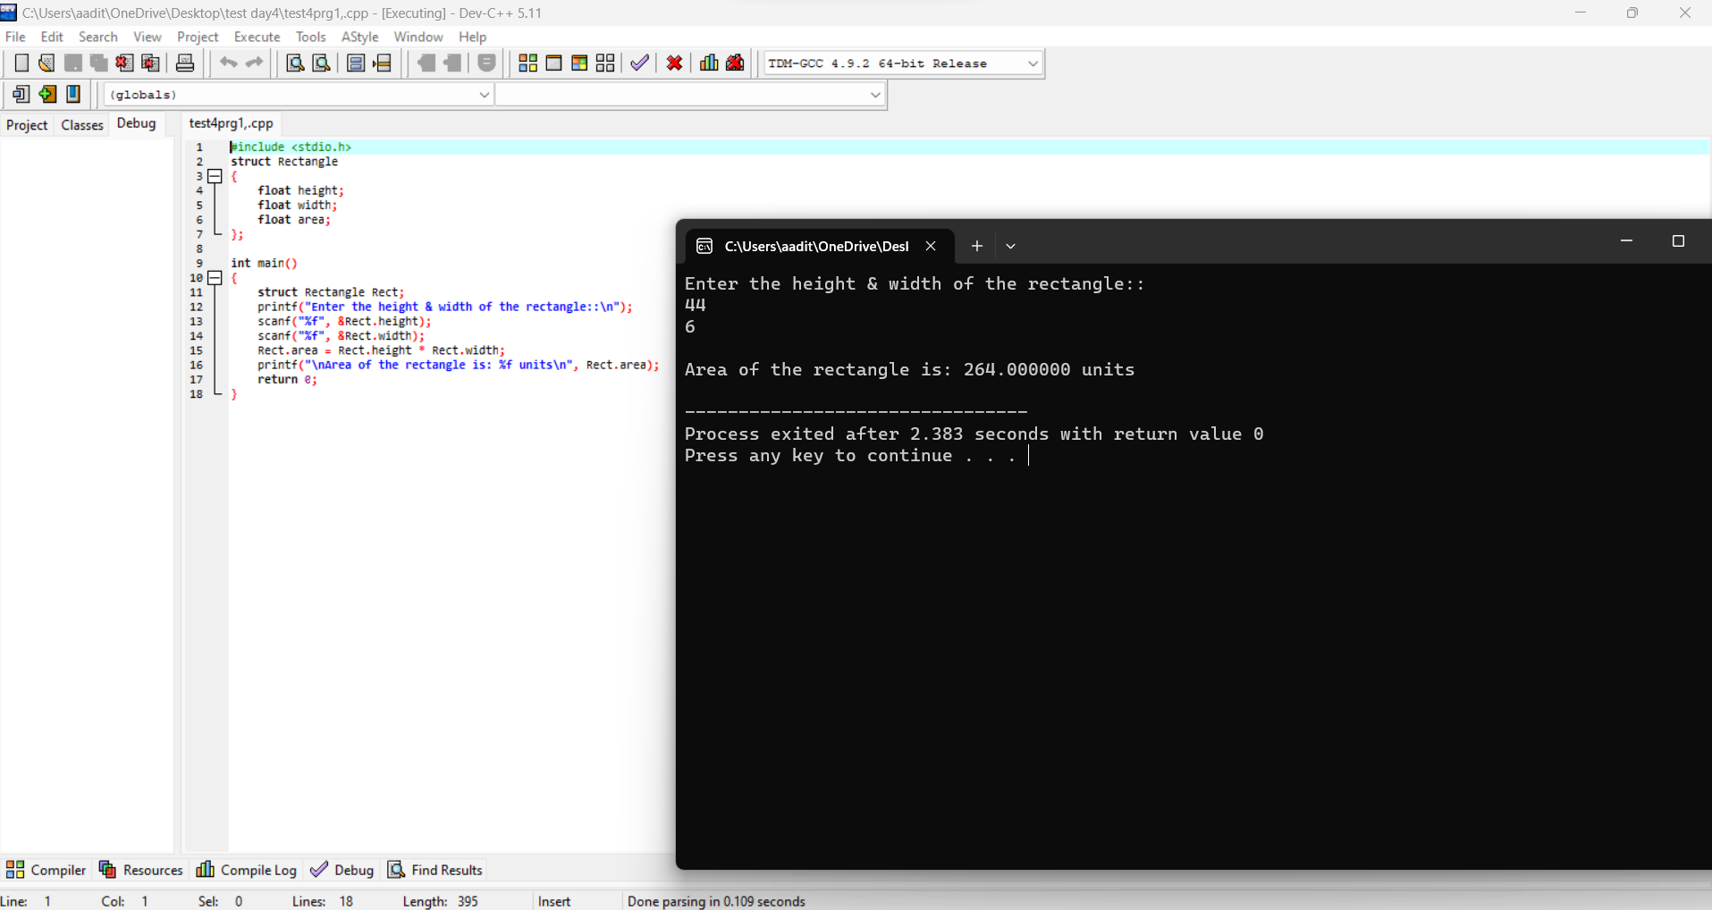

# to merge two array

